Moving a DreamGrid to another folder or PC
There are no dependencies outside of the DreamGrid folder to copy to a new location.
Stop the original grid and go to Setup->Setting->Caches. Select and clear all the caches. These do not need to be copied and are huge. Opensim will recreate them as needed. The states of scripts will be maintained.
Now copy the entire folder from one machine to the other or from one folder to another.
Another method is to unzip a new copy of DreamGrid on the destination machine. Then copy the file Outworldzfiles\Settings.ini, Outworldzfiles\mysql\data, and Outworldzfiles\opensim\bin\regions to the second machine or folder.
If you are running the Apache web server (for jOpensim Or Maps), install the service packs in Setting->Apache, which is also in the folder MSFT_Runtimes.
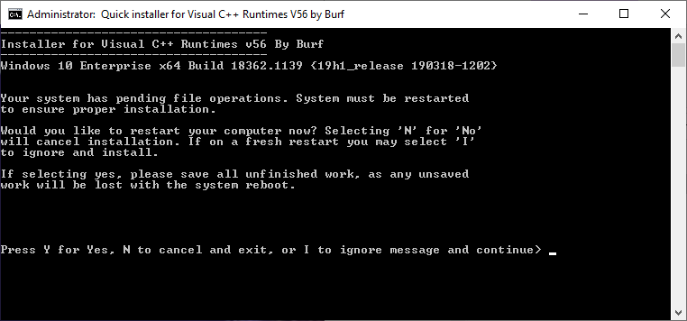
It may ask to reboot. There is no need to reboot. If it asks, type 'i' to ignore, then 'y' to install.
Router: You will need to port forward to the new IP if you are on the hypergrid.
Anti Virus: If setting up a new computer, you will want to check that any 3rd party anti-virus is not blocking ports. Also add an exclusion to the Opensim\bin folder to the Real-time component of any virus scanner as this area gets heavy use of Script DLLS, and it will cause issues with scripts starting up or being created. Opensim does not create viruses, and all my code is digitally encrypted and signed by Microsoft Authenticode and will not run if even a single bit changes.

